Gateways to Discussion: The Diversity
& Inclusion Casebook

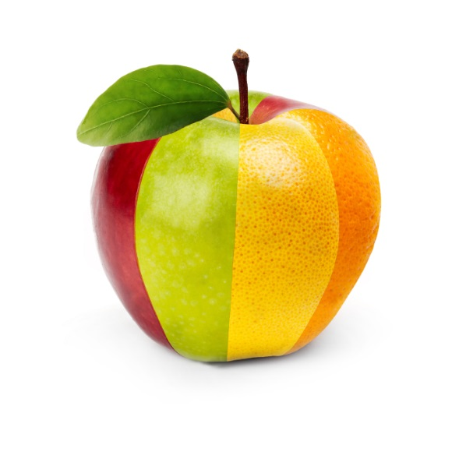

Gathered and Developed by:
Sondra Thiederman, Ph.D.
Cross-Cultural Communications
619-583-4478
stphd@thiederman.com
www.thiederman.com

